**Tea Scheduler**

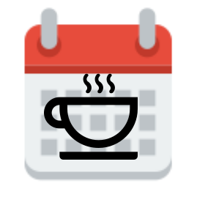

*Ryan Tolentino*

*Miguel Castro*

Date Submitted: 03/29/2018

**Executive Summary**

One leading cause of trouble for American military personnel is rape or sexual assault. The team decided to create an application that allows two parties to make a form to give consent before partaking in a sexual activity. For our development cycle, the team drew out the application, start coding the controller for the web application, start adding the design of the application, and finally testing the application. The team will continually update and optimize the application until the due date.

The team made assumptions to bound the scope of our project. We assume, that there are two end users and a server in the test environment. For our project, we assume one user is male and the other is a female. We assume that the end users and server are in the same internet space.

For our app, we are developing for a multiple user with in mind. As of now, we are using a two-person interaction with one another to simulate scheduling an event. We also assumed that both parties exist as a male and a female to schedule an event, otherwise it would go against our test cases. We assumed that both parties are in the same network, otherwise they will not be able to communicate.

# 

# 

# 

# 

# 

# 

# **1.** **Problem Statement**

The team was tasked in choosing a topic for their senior project. The team took a deep investigate what was a problem today. We discovered that there were a lot of American soldiers getting into trouble with the law because of rape/sexual assault. Therefore, we decided to create a web application that allows the two partners to send each other a form requesting that they give permission to perform sexual activities. Due to the controversial topic, we reworked our application to remove the sexual aspect, and make a scheduler app for both parties.

1.1 Draw out the application

The team must create a flow diagram and draw out how the web application should function. The team must develop a simple but safe design. We further concatenate any improvements within the logic of our program.

1.2 Start coding the controller for the web application

The team must start working on the controller for the web application. The controller must allow an email or SMS message to be sent to an individual and then that person will then accept or deny the request and a record will be stored within the database.

1.3 Start adding the design of the application

The team will then start designing the application and making the application more user friendly. It should be easier to access within the different pages for a smooth experience. Once that is achieved, we move to testing the application.

1.4 Testing the web application

The team will then begin the final stages of testing. The team will then use a variety of test cases to ensure no flaws in the design. In the event of a flaw the team will then repeat steps 1-4.

# **2.** **Background**

**2.1 Model View Controller**

Web2py separates the data representation (the model) from the data presentation (the view) and the application logic and workflow (the controller).

**3.** **Assumptions**

We assume, that there are two end users and a server in the test environment. For our project, we assume one user is male and the other is a female. We assume that the end users and server are in the same internet space.

**4.** **Techniques and Tools**

**4.1 Web2py**

Web2py is a free open-source web framework for secure database web application. The application uses python and includes a database abstraction layer; therefore, it knows how to generate SQL by itself. The software should translate the code into a proper webpage where a user can interact and send an event request to another user.

**4.2 SQLDB**

A database is used for a structured set of data held in the computer. This database holds important information such as user information and controller for scheduling an event. In our application we will be using an SQLDB.

**4.3 Draw.io**

Draw.io is a program that allows a user to draw diagrams and flowcharts. We will be using draw.io to create our flow charts and other graphics.

**5** **Problem Solution**

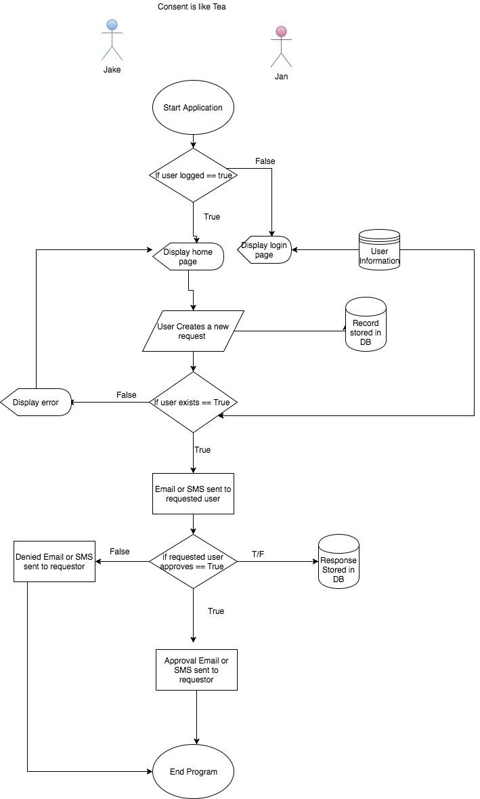

**6. Risk Assessment**

For our app, we are developing for a multiple user with in mind. As of now, we are using a two-person interaction with one another to simulate scheduling an event. We also assumed that both parties exist as a male and a female to schedule an event, otherwise it would go against our test cases. We assumed that both parties are in the same network, otherwise they will not be able to communicate.

# **7.** **Timeline**

Jan 31: Initial meeting with advisor [Dr. Wu]

Feb 1: Project title/synopsis [Consent App]

Feb 8: Made a GitHub repo [Senior Project]

Feb 13: Meeting with Dr. Wu to talk about proposal

Feb 13: Start app development

Feb 15: Proposal Paper

Feb 26: Developed prototype application: <https://web.uncfsu.edu/tea>

Mar 2: Must revise project due to controversial topic

Mar 3: Decided on making a tea scheduler app. Has the same functionality as previous project.

*** team meetings every Tuesday at 4:30 pm - 6:00 pm ***